Fundamentals of Data Base
LAB
FAROOQ AHMAD EXPERIMENT 6
17L4407
BEL-8A1
Exercise 1
i. select fname, lname
from employee e inner join dependent d on e.ssn=d.essn
union
select e.fname, e.lname
from DEPARTMENT d inner join employee e on e.ssn=d.Mgr_ssn
order by fname, lname
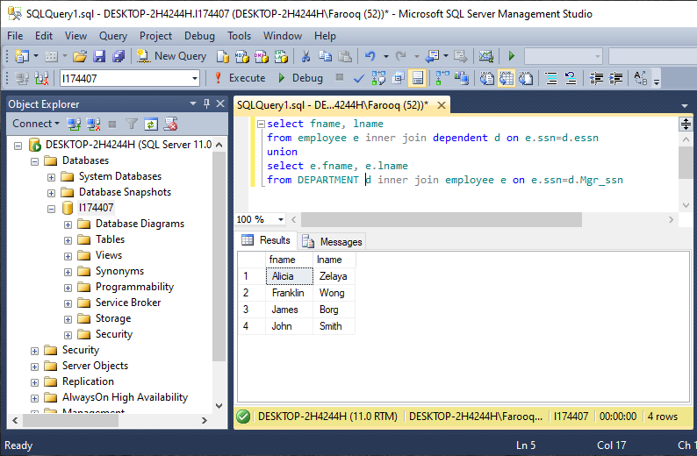
It executes the OR condition, displays the employees present in both queries without duplicating them.
ii. select fname, lname
from employee e inner join dependent d on e.ssn=d.essn
union all
select e.fname, e.lname
from DEPARTMENT d inner join employee e on e.ssn=d.Mgr_ssn
order by fname, lname
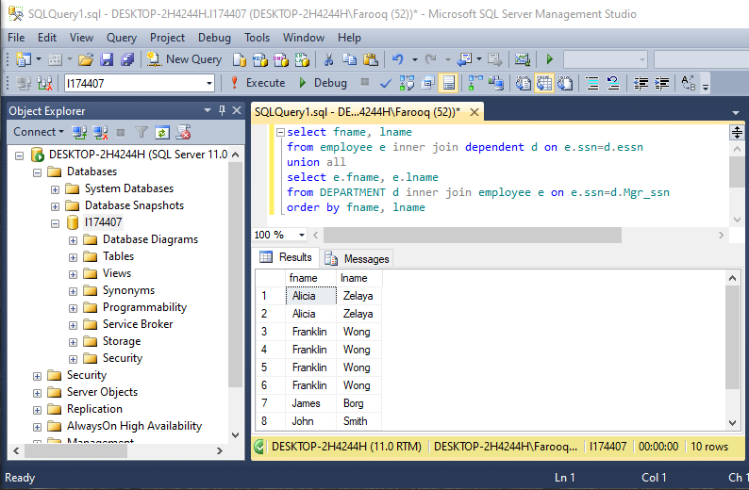
It executes the OR condition, displays the employees present in both queries but does not eliminate the duplicates.
iii. select fname, lname
from employee e inner join dependent d on e.ssn=d.essn
intersect
select e.fname, e.lname
from DEPARTMENT d inner join employee e on e.ssn=d.Mgr_ssn
order by fname, lname
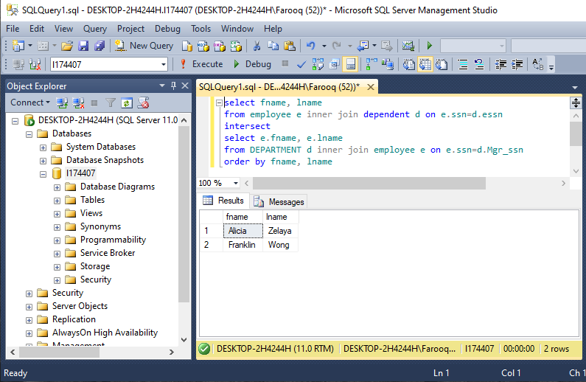
It executes the AND condition. Brings back the employee(s) which are present in both the queries.
iv. select fname, lname
from employee e inner join dependent d on e.ssn=d.essn
except
select e.fname, e.lname
from DEPARTMENT d inner join employee e on e.ssn=d.Mgr_ssn
order by fname, lname
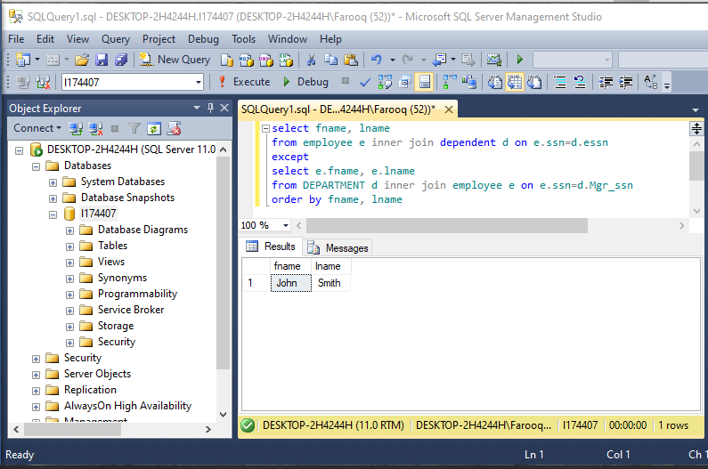
It removes the employees in the second query from the first query. It works as a MINUS condition. Query 1 minus Query 2. It eliminates the employee(s) from the query 1 if they are present in query 2.

Exercise 2
v. select fname, lname from employee
where salary =(select MAX(salary) from employee)
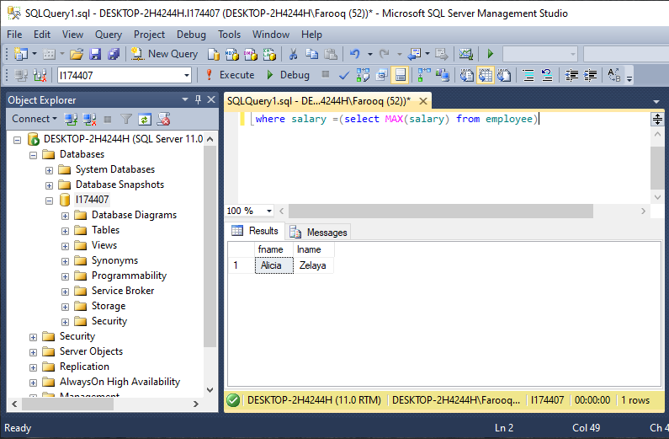
It is using an aggregate function in a sub query where it is returning the employee name with maximum salary.
vi. select fname, lname
from employee where ssn in (select essn from dependent)
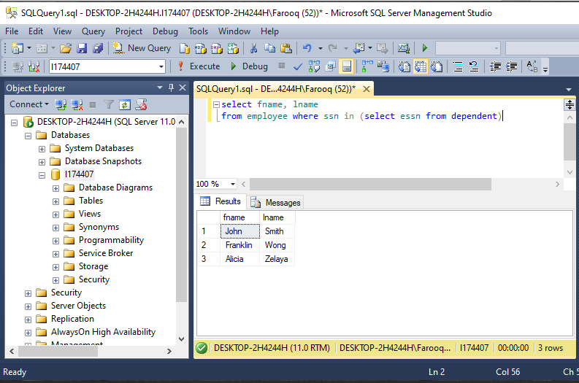
it uses an in statement for checking if an employee is a dependent by checking if an employee’s ssn is present in the dependent table’s essn (e.ssn = d.essn) which concludes that the employee is dependent
vii. select fname, lname
from employee where ssn = any (select essn from dependent)
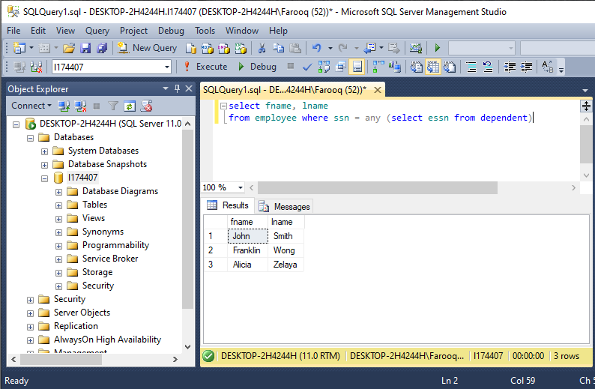
This query returns the names of the employee whose ssn matches with any essn from the dependent table. It is same as the in statement
viii. select e.fname, e.Lname
from employee e where exists (select * from dependent d where
d.essn=e.ssn)
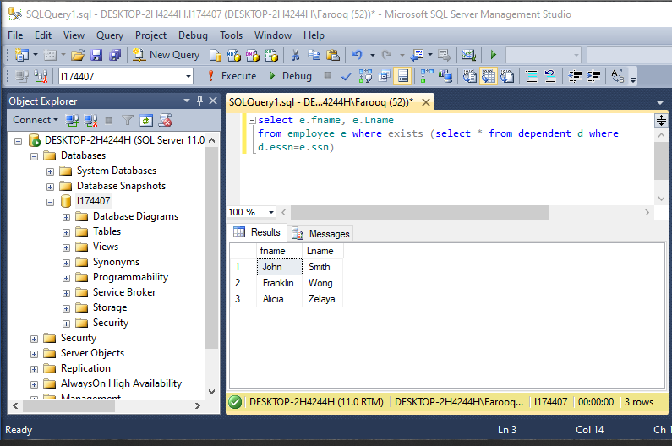
It is also doing the same task
ix. select d.dname
from department d join dept_locations lo on d.Dnumber=lo.Dnumber
group by d.Dname, d.Dnumber
having COUNT(*)&gt;=all(select COUNT(*)from dept_locations li group by
li.dnumber)
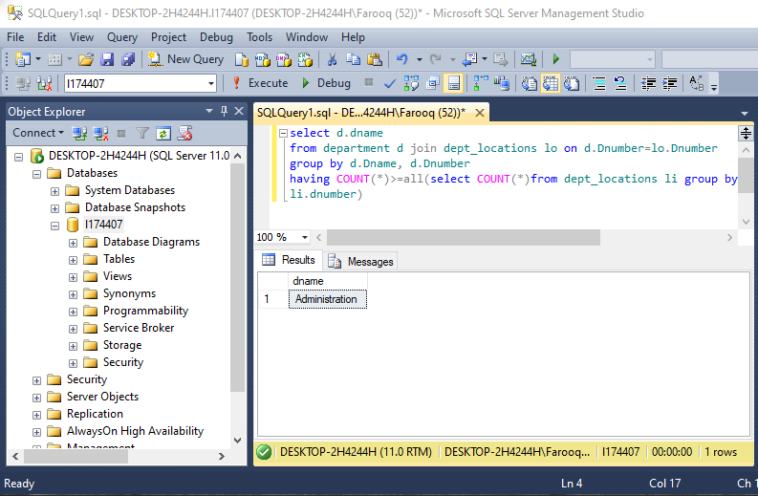
Exercise 3
1. Give the name(s) of employees who work either on project “ProductX” or on
project “ProductY”
select e.fname+' '+e.lname
from employee e inner join works_on w on e.ssn=w.essn
inner join project p on p.Pnumber=w.Pno
where p.Pname='ProductX'
union
select e.fname+' '+e.lname
from employee e inner join works_on w on e.ssn=w.essn
inner join project p on p.Pnumber=w.Pno
where p.Pname='ProductY'

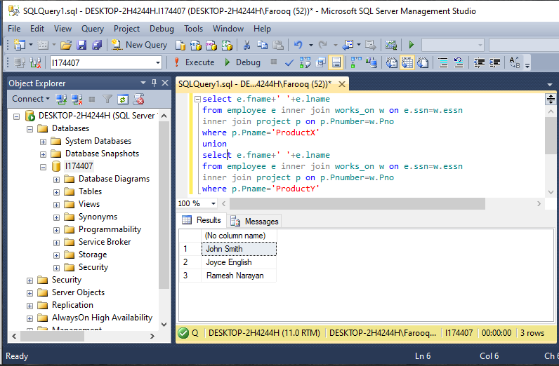
2. Give the name(s) of employees who work both on project “ProductX” or on
project “ProductY”
select e.fname+' '+e.lname
from employee e inner join works_on w on e.ssn=w.essn
inner join project p on p.Pnumber=w.Pno
where p.Pname='ProductX'
intersect
select e.fname+' '+e.lname
from employee e inner join works_on w on e.ssn=w.essn
inner join project p on p.Pnumber=w.Pno
where p.Pname='ProductY'
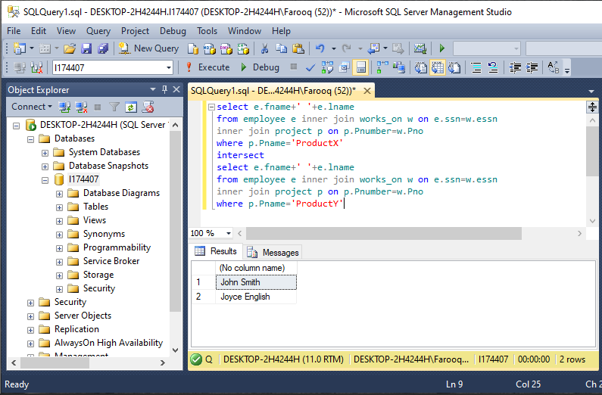
3. Give the name(s) of employees who work on project “ProductY” but not on
project “ProductX”
select e.fname+' '+e.lname Employee_Name
from employee e inner join works_on w on e.ssn=w.essn
inner join project p on p.Pnumber=w.Pno
where p.Pname='ProductY'
except
select e.fname+' '+e.lname
from employee e inner join works_on w on e.ssn=w.essn
inner join project p on p.Pnumber=w.Pno
where p.Pname='ProductX'

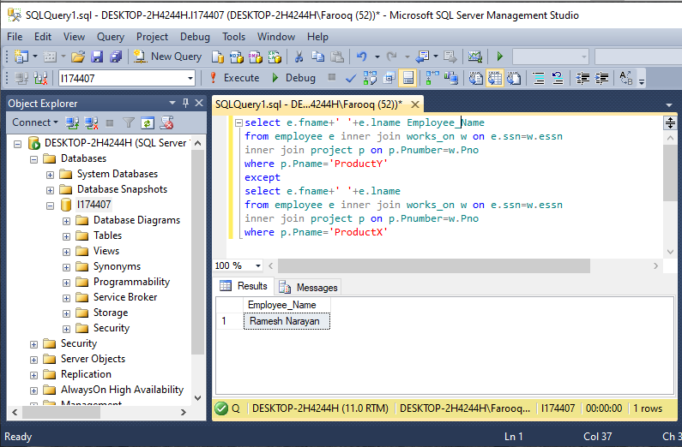
4. Give the name(s) of employees who earn the minimum salary.
select fname+' '+lname Employee_Name
from employee
where salary =(select MIN(salary) from employee)

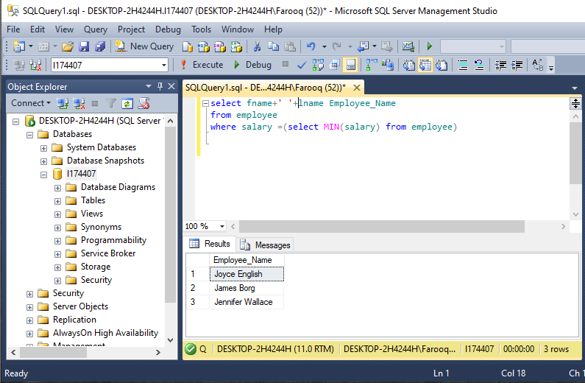
5. Give the names(s) of employees who work on as many projects as “Jennifer
Wallace”. Please exclude “Jennifer Wallace” from the list.
select e.fname, e.lname
from employee e inner join works_on w on e.ssn=w.essn
group by e.fname, e.lname
having count(w.Pno) = count(*)(select pno
from works_on
where essn = (select ssn from employee
where fname like 'Jennifer' and lname like 'Wallace'))
except
select e.fname,e.lname
from employee e inner join works_on w on e.ssn=w.essn
where e.fname like 'Jennifer' and e.lname like 'Wallace'
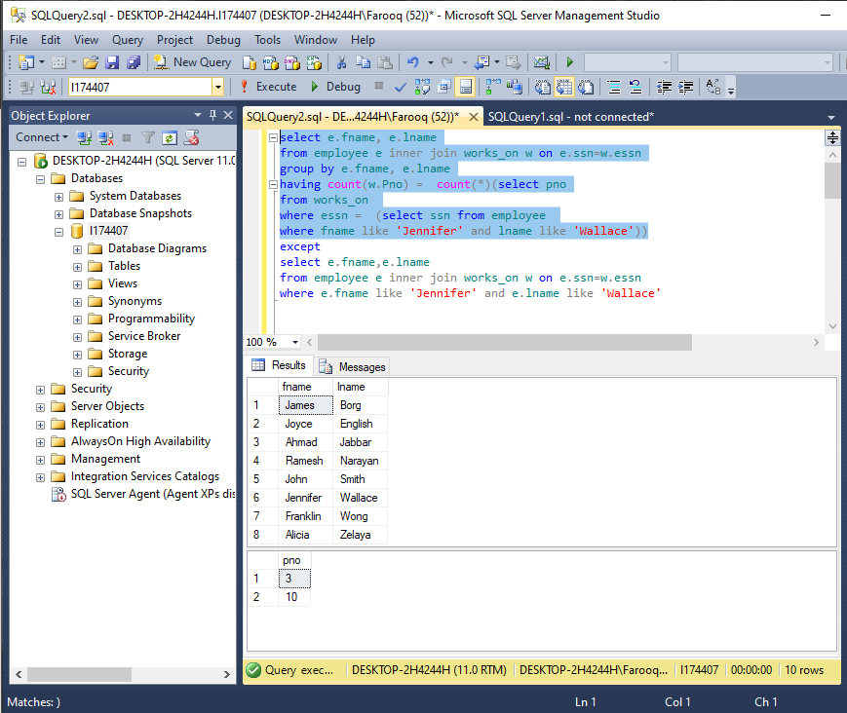
6. Give the names(s) of employees who work on a project which is not controlled by
their own department.
select e.fname, e.lname
from employee e inner join works_on w on e.ssn=w.essn
inner join project p on p.Pnumber=w.Pno
where p.Dnum != any (select Dno from employee)
